<https://coding-boot-camp.github.io/full-stack/mongodb/deploy-with-heroku-and-mongodb-atlas>

MONGODB_URI set as environment variable in .env file

Process.env.MONGDB_URI 🡪 like jawsdb

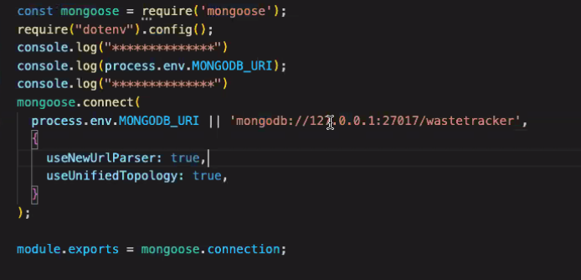

<https://cloud.mongodb.com>

🡪database access 🡪 click edit here and make access

Database 🡪 cluster (has multiple connections) 🡪 connect 🡪 replace password with password from access thing